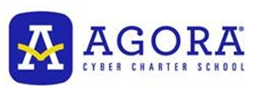
1018 W 8th Ave.
King of Prussia, PA 19408

RE: Letter of Recommendation for Raja Krishnaswamy

To whom it may concern,
It is with pleasure that I recommend our very excellent student, Raja Krishnaswamy. Currently, he is distinguishing himself academically with a 99% average in my AP Computer Science A class. Last year he achieved an unqualified 100% in my AP Computer Science Principles class. In my eighteen years of teaching, I have not seen a student of this caliber and he would certainly be an asset to your school. Not only is the quality of his work superior, but he leads his fellow students in group discussions, and he is willing to help his peers. Both in group and solo projects, he manifests a competence, integrity, and intuitive grasp of programming concepts.
Not only does Raja fulfill the requirements of each project in a timely manner, but he goes the extra mile and extends himself beyond the requirements of assigned work. He enjoys giving that extra polish in every project and adding his own personal touches. He is considerate of other’s opinions and gives attention to the detailed requirements, documentation, and research required in each assignment.
Raja is excelling in every course he is taking: Honors American Literature, AP Macroeconomics, AP Microeconomics, AP Calculus, and AP Chemistry. All grades are above 95% and he is concurrently taking college courses as well. Raja is also active in FBLA, the model United Nations Club, and National Honor Society.
I believe that you will be pleased to have Raja at your school. If you have further questions, or need more details, feel free to call me at (610) 230-2718

Sincerely,
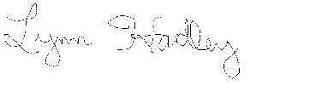
Lynn Hadley, MA
Business Education teacher
