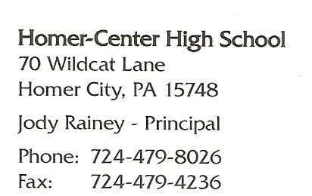

September 24th, 2017
To Whom It May Concern,
This letter is regarding Cameron cox, a student I had the opportunity to teach three consecutive years in row.
He has strong problem solving skills, a desire to take part in as many opportunities as possible, and is a leader in the Derry Area High School District. The classroom is only a small part of Cameron’s life where he has seen continued success.
Cameron’s academic life includes a 4.0 GPA as well as being part of National Honor Society. He is revered as a leader among his peers having been elected Class President of the 2019 graduating class. Cameron was also elected Class President of the EWCTC – Eastern Westmoreland County Career and Technology Center.
Cameron is that student that interacts with all students, approachable from any peer group and across the ability spectrum. He can converse at a high intellectual level with the adults in his academic world, and then turn around to effectively communicate with students where he explains high level conceptual information in a format which they can understand. He peer tutored in my class where he took it upon himself to translate topics in class without watering it down to help students struggling with the academic vocabulary.
Cameron is very responsible and holds his peers to the same standards. He reminds them of projects, their responsibility within the parameters of the project, and helps his partners set goals. His ability to break down large assignments into manageable bites and translating difficult information to understandable conversations led him to earning multiple Microsoft Certifications, internships at his technical training center in Westmoreland County and at LV Tech - Derry Area School District’s IT consulting firm.
Cameron Cox is a true team player. When those students around him need to hear an explanation in a different voice, he chooses to be that voice. Cameron stepped up to be Drum Major in the Derry Area Band to lead his peers on the field for Marching Band. Cameron also takes time out of his busy life to volunteer to help those in his community. He volunteers his time at the school track meets and in the school event which raises money for Children’s Hospital of Pittsburgh.
Cameron quickly takes in new information and makes it his own. He problem solves under pressure, he cares for others and takes time to volunteer in his community. He opens himself to a variety of experiences available to students his age. Cameron Cox will be a great student in any program he pursues. He goes above and beyond expectations. If you have any further questions about Cameron Cox, feel free to contact me.
Sincerely,

Brad Adams
badams@homercenter.org

