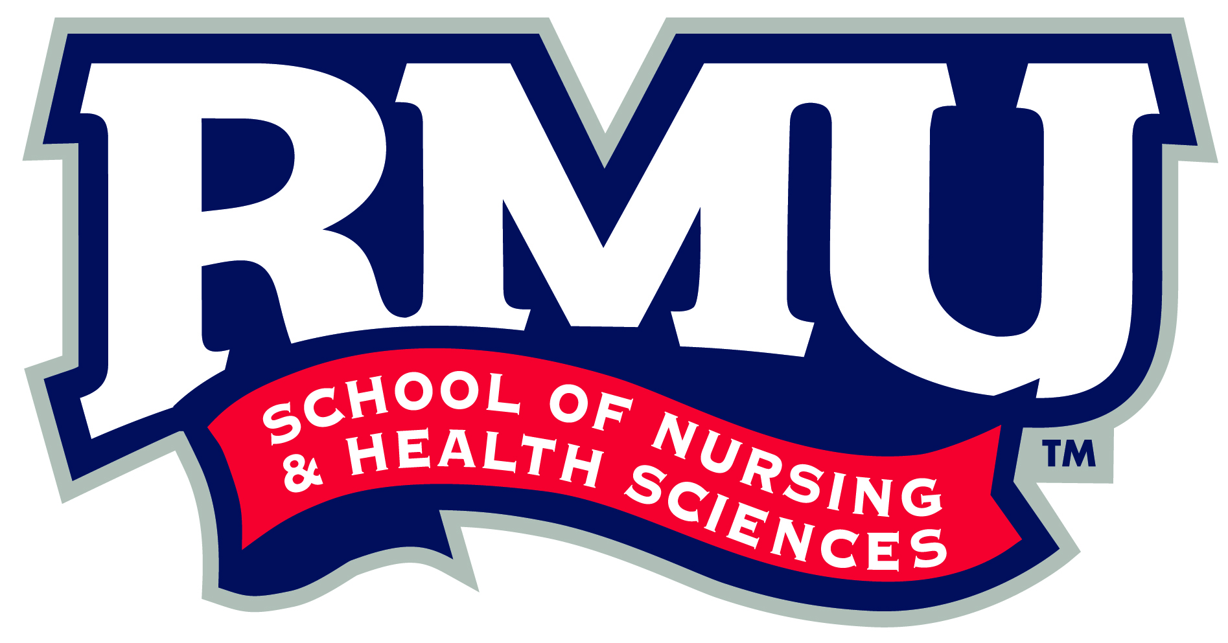 March 2, 2020

School of Nursing and Health Sciences

Robert Morris University

6001 University Boulevard

Moon Township, PA 15108

412-397-3000 phone

412-397-3277 fax

**RMU.EDU**

To whom this may concern:

This letter is in reference to Abby (Abigail) Messner who is applying for the Tribune Review Outstanding Young Citizen Scholarship. I have known Abby and her family from the time she was born. Her mother cared for my 4 children for years and Abby would come with her mom during her first few years. As a university professor, I have written hundreds of reference letters. I can honestly say, this is one I feel passionate about writing.

There are several attributes that make Abby deserving of this award. She is a hard worker and applies herself fully in everything she does. Abby obtains A’s on her report card and always makes the honor roll. She exudes a gentle attitude and a quiet confidence. Her leadership ability has blossomed at Our Lady of the Sacred Heart (OLSH) High School.

Abby participates in multiple diverse activities. For example, she is actively involved in theatre and as a student ambassador at her high school. She is also on the prom committee and serves as VP of her senior class. She is musically gifted and has served as a cantor at St. Malachy Catholic Church in Kennedy Township. In addition, she and her family serve as volunteers in multiple capacities at St.Malachy, OLSH and Pittsburgh Musical Theater. These activities have allowed Abby to develop leadership qualities that will only expand as she begins college.

Abby’s mom has been diagnosed with Multiple Sclerosis; however, she does not use this as an obstacle. She uses her gifts to her fullest ability and continues to work outside the home. Without financial assistance, it would be difficult for Abby to attend a college/university that she feels drawn to. Abby will be the first from her family to obtain a college degree and I, along with her own family would love to see her reach that goal. Obtaining a college degree will be a dream come true for her and it would be an honor to see Abby graduate from college in 2024!

Sincerely,

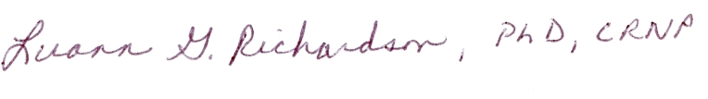

Luann Richardson, DNP, PhD

Professor, RMU School of Nursing, Education and Human Studies.